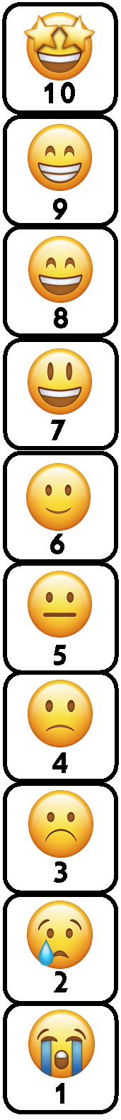 | 10. Today is a great day!
 | 9. Today I am good. I am hopeful for today.
 | 8. Today is going well. I hope the rest of the day will too.
 | 7. Today I am good so far.
 | 6. I am having an ok day. I think it could go up or down.
 | 5. Today I am up and down. I’m in the middle.
 | 4. Today I am feeling a bit down. I am worried how the rest of the day will go.
 | 3. Today I feel down. I will need the support of my friends.
 | 2. Today is a sad day. Things have happened that do not usually happen and I need extra support.
 | 1. Today is one of the worst days I have experienced. Things have happened that have shocked me and made me feel very sad. I need extra help today.

