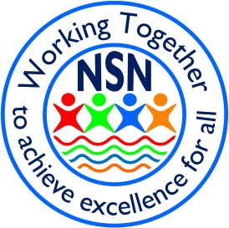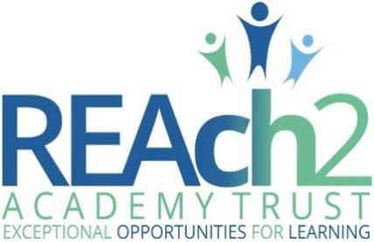

SEND Information Report 2021-2022

At Northfield St Nicholas Primary Academy, we believe that all children can achieve.
We provide a broad and balanced curriculum for every child, which meets individual needs. We do our best to make sure every child is happy and settled so that they can achieve their best and enjoy a wide range of educational experiences we have to offer.

What kind of SEN are provided for at NSN?

Northfield St Nicholas Primary Academy School is an inclusive school and offers a range of provision to support children with Special Educational Needs and Disabilities (SEND), which include language, communication and interaction needs, learning difficulties, social, behavioural and emotional health difficulties, sensory difficulties and physical needs.
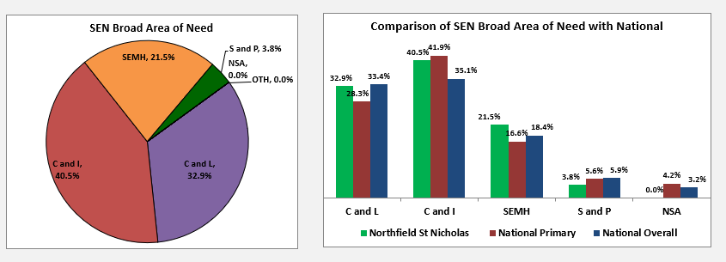
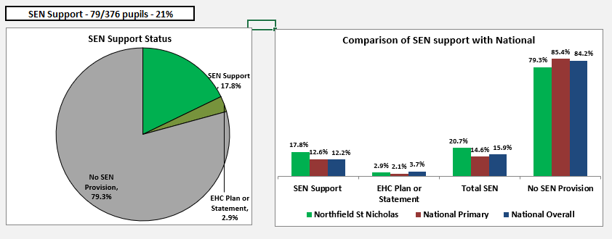

How does Northfield St Nicholas Primary Academy know if children need extra help and what should I do if I think my child may have special educational needs?

All class teachers regularly assess the progress of all children. Pupil Progress Meetings are held regularly with the class teacher and the senior leadership team in order to discuss the children’s progress. Class teachers also have a SEND pupil progress meeting with the Special Educational Needs Co-ordinator (SENCO) to discuss identified pupils and pupils of concern. Class teachers and SENCO apply what is called a ‘graduated approach’ to support pupils with SEN. This means that we identify and plan a graduated approach of support to ensure that your child gets the effective support at the right time.

If your child is then identified as not making expected progress, or the teachers have concerns about your child’s talking, listening skills, physical development, or any other areas of development, the school will set up a meeting to discuss this with you in more detail and to:
- listen to any concerns you may have
- plan any additional support your child may receive
- discuss with you any referrals to outside professionals for assessments to support your child’s learning
- with your agreement, place your child on the SEN register

Your child’s class teacher is always the first point of contact for any concerns. If you are worried that your child may have special educational needs and/or a disability (SEND), you may also want to speak to the Special Educational Needs Co-ordinator (SENCo).

Who is responsible for Special Educational Needs? Who should I contact for help or more information?

Your first contact for any concerns will be the class teacher who then may decide to refer you to the Special Educational Needs Coordinator (SENCo). The school’s special educational needs coordinator is Miss Higgins.
The SENCO is responsible for:
- coordinating all of the support for children with SEND and developing the school’s SEND Policy to make sure all children get a consistent, high quality response to meeting their needs in school
- ensuring that you, as parents/ carers, are involved in supporting your child’s learning and kept informed about the support your child is getting
- liaising with external agencies who may be coming into school to help support your child’s learning e.g. Speech and Language Therapist, Educational Psychologists, occupational therapist etc. updating the school’s SEND register (a system for ensuring all the SEND needs of pupils in this school are known) and making sure that there are records of your child’s progress and needs
- maintaining the school Map of Provision which lists all types of support every child on the SEN register has
- providing specialist support for teachers and support staff in the school so they can help children with SEND in the school achieve the best progress possible
- reporting progress of children with SEND to the Senior Leadership Team
- running effective Professional Development sessions for teaching staff or organise high quality INSET for staff to attend to increase skills and knowledge to meet a particular need

What support is offered for children with SEND? How is the decision made about what type and how much support my child will receive?

The class teachers review the progress of all their children with the SENCo and Head Teacher termly. At these meetings any children who are not making expected progress will be discussed and any extra support that is necessary can be planned. We know that excellent teaching by the class teacher is the most important factor to ensure that children are achieving at school. For children with SEND this means
- the teacher has a strong knowledge of your child’s need and learning style
- all teaching is based on building on what your child already knows, can do and can understand
- different ways of teaching are in place so that your child is fully involved in learning in class. This may involve things like using more practical learning
- the teachers and LSAs are utilized to add support and scaffold learning where it is needed most
- specific strategies (which may be suggested by the SENCO or outside staff) are in place to support your child to learn
- progress of your child is checked and reviewed regularly

Although it is desirable that most learning for pupils with SEN and disability takes place in the social context of the mainstream classroom, if specific needs or gaps in learning are identified which need to be addressed, your child may need to attend an effective and bespoke learning intervention away from the main classroom. These are usually in small groups or on a 1:1 basis and might be for a fixed period. Before starting any bespoke learning, it will be discussed with you by your child’s teacher or SENCo. There are a range of bespoke learning opportunities including:
- Catch up reading programme
- Catch up phonics groups
- Catch up maths
- Speech and language therapy programmes
- Social skills groups
- Fine and Gross Motor skills groups
- THRIVE group
- BEAT dyslexia
- Listening Ear Service
- Interventions suggested by outside agencies

How are the school’s resources allocated and matched to children’s special educational needs?

The school receives High Need Funding for SEND provision for those pupils with particularly high need. This funding is used to fund support staff, buy resources, run intervention programmes and access training. The allocation of funding is reviewed each year as the needs of the current SEND children are assessed. The allocation of this budget and the support that has been provided will be reviewed and evaluated yearly by the SENCo, the Head teacher and the Governors. The school has a duty to inform Suffolk County Council how it is using the resources provided for these children.

What are the arrangements in consulting with parents? How are parents involved in the school? How can I be involved?

At Northfield St Nicholas Primary Academy we value the contribution that Parents and Carers make to the school and offer many opportunities to be involved. We hold regular parent-teacher meetings to discuss progress, attainment, learning plans and consistent behaviour management plans of children.

At Northfield parents are welcome to make a SENCO Surgery appointment. We encourage our Parents/Carers to come into school to discuss any concerns and thoughts with us at any time. We ensure that parents can contact us by phone or email and through informal discussions. We hold drop-in training sessions and individual appointments for deeper discussions around the needs of the child based around children’s individual needs.

Parent and carers are also welcome to attend our half termly coffee mornings and encouraged to read our termly SENCO newsletters to keep up to date with the school’s Assess, Plan, Do, Review cycle.

What are the arrangements for consulting with my child about their SEN needs?

At Northfield St Nicholas Primary Academy we ensure all pupils voice are captured by taking a person-centered approach. We do this by teaching and LSA discussing learning plans with pupils and leaders capturing pupils voice during monitoring. The SENCO also regular meets with pupils to discuss their progress, learning and provision.

How will school communicate about children’s progress? How will school help me to support my child’s learning?

We have parent -teacher meetings each term to discuss progress and set targets. We also provide a written report at the end of the year, as well as, a copy of learning plans termly.

The class teacher is regularly available to discuss your child’s progress or any concerns you may have and to share information about what is working well at home and school so similar strategies can be used. If you have been working with the SENCo, the SENCo will be available to meet with you to discuss your child’s progress or any concerns/worries you may have. She is available to parents when needed and is contactable through SENCO Surgeries, phone, email. She will meet you regularly to discuss your child’s progress and ensure their needs are being met. All information from outside professionals will be discussed with you and the external agency involved directly and you will be provided with a written report. The report will suggest strategies that we can use at school and at home to support your child.

How will school staff support my child?

The class teachers are responsible for planning and delivering high quality teaching for all the children in their classes. The SENCo is responsible for overseeing the provision for all the children with SEND in the school and will support the class teachers to teach the children in their classes who have additional/different needs. The SENCo also co-ordinates the SEN support staff who work with children that have complex needs. If your child has a high level of SEND, he/she will have a support plan which shows how your child will be supported to meet their needs. This will be agreed by you, the class teacher and SENCo. The SENCo is responsible for supporting the Teaching staff to understand the needs of children with SEND and helping them to best support them.

How will the curriculum be matched to my child’s needs?

All class teachers are expected to provide challenge matched to the pupils’ abilities and needs in all lessons so that all children receive the appropriate level of support to help them to make progress. This may be done through giving children slightly different tasks, giving them more resources to help them complete the task or giving them more adult support. Some children will need to work at a different level and/or pace to other children and the class teacher will be supported by the SENCo to plan for this.

What specialist services and expertise are available at or accessed by the school?

In addition to the school SENCo, who holds the SENCo qualification, we also have:
- LSAs trained in delivering speech and language groups and other interventions
- THRIVE trained practitioners
- An excellent pastoral support team
- Key adults who support vulnerable children throughout the day, especially during unstructured parts of the day
- LSAs trained in delivering interventions such as catch up maths, patch up reading, phonics interventions and social skills to name a few

The school works with a number of external agencies to seek advice and support when needed to ensure that the needs of all children are fully met. We refer children for assessment and advice from a wide range of other professionals, including:
- Specialist Education Services (SES): Cognition and Learning, Communication and Interaction, SEMH and Sensory/Physical, Graduated Response Stage 3, Whole School Inclusion Service and The Alternative Tuition Service
- Support for learning services- Hearing/ Visually Impaired
- Our School Nurse
- Occupational Therapy
- Physiotherapy
- Point 1 and CAMHS - Child and Adolescent Mental Health Service
- Children’s Social Care
- Educational Psychologist

If school think that a referral to one of these professionals is needed the SENCo will speak to you. If you feel your child needs extra support from one of these agencies please see the class teacher or the SENCo.

What training have the staff supporting children and young people with SEND had?

All staff have regular Safeguarding training and up to date training on the new SEN legislation. They are regularly updated and supported on how to identify children with special educational needs through training sessions or termly meetings with the SENCo. The school has a comprehensive programme of professional development which includes training from the SENCo and outside experts on many areas of SEND. The SEN support staff have regular staff meetings in which SEN updates are discussed. SEN staff are continually being supported to increase their awareness and knowledge of SEND. Support staff who work with children with SEND will access outside training specific to the children’s needs. They are constantly upskilling themselves to meet the needs of the children in their care.

How will my child/young person be included in activities outside the classroom including school trips?

We always aim to include everyone in trips and activities and will work with the family to make sure children with SEND can be included by making reasonable adjustments to travel arrangements, support arrangements etc as needed.

How accessible is the school environment?

As part of our School Accessibility policy we ensure that the school is assessable to all our children. Where necessary we will ensure that arrangements are made to cater for ongoing needs for all our children. This may be a habituation report for children with visual impairment or ensuring that all areas are able to be accessed for a child who uses a wheelchair for example. When needed we can access interpreters/ advocates when necessary for meetings with families and other professionals for families for whom English is not their first language.

What are the arrangements for assessing and reviewing children and young peoples’ outcomes?

SEND assessments take place formally at least 3 times a year. These assessments directly feed into your child’s learning plan targets and support progress reviews. Parents are invited to feed into the review of pupils’ assessments through learning plan meetings. The types of assessments that take place depend on each individual child’s needs.

What are the arrangements for supporting transition including educational phases?

The SENCO meets with all year 6 parents whose pupil is identified as SEN to begin an agreed transition plan to support high school. This is then regular updated throughout the year. Those pupils who are moving between key stages with an EHCP hold the Annual Review in the Autumn Term before the transition in order to provide a formal opportunity to plan transition with parents and all other agencies involved. Pupils who are moving between year group have transitional support in the summer term dependent on their individual needs and circumstances.

What support for improving emotional and social development is there at Northfield and are they any additional measures in place through pastoral support arrangements for listening to the views of children and young people with SEN and measures to prevent bullying?

At Northfield St Nicholas Primary Academy Mental Health support is provided through a whole school approach called THRIVE. THRIVE is an approach which promotes children’s social, emotional, mental health and wellbeing. A Graduated Approach is applied to support SEMH by: -
- All class teachers complete a THRIVE assessment which identify whole class action plans.
- Daily check ins before, middle and end of every day to help children to communicate their feelings and identify their emotions. This is supported with visuals to support SEN.
- Restorative Practice conversations are used as a whole school approach to help develop pupils understanding. Comic Strip conversation and a visual script is used to provide additional support for those with SEN.

Pupils identified a higher level of mental health need can access mental health support through: -
- THRIVE practitioner 1:1 intervention
- Small THRIVE group work
- Social Skills groups
- YMCA 1:1 intervention
- YMCA small group work
- Point 1 referral
- CAMHS referral
- SES teacher support

The SENCO also meets termly with the Restorative Practice and Anti-Bullying Lead to analysis data, treads and identify any pupils who may need additional support.

How will Northfield St Nicholas Primary Academy prepare and support my child to join the school and transfer to a new school?

All children who join the school mid-year will be assessed to find out what support they may need, if any. For children who have already been identified as having SEND the SENCo will liaise with the previous school to see what support was in place and gather all the necessary information as well as meeting with the parent/carer to discuss the child’s needs. Transition between classes and key stages will be supported for all children. For children with SEND, who may find the change more difficult, a social story may be used, extra visits or other planned activities will be implemented to aid the transition. The SENCo is responsible for sharing SEND information when the children move on to secondary school and for some children a transition meeting will be organised with the family and the Secondary SENCo. The Secondary SENCo will be invited to Year 6 annual reviews so that they have the opportunity to meet the child and his/her parents before the transition. The SENCO will also invite Year 6 Parents to meet to discuss concerns or ideas which will help support their child’s transition to high school. A transition plan will then be created to support transition.

What arrangements for handling complaints from parents of children with SEN about the provision made at the school?
All complaints should follow the school complaint procedure.

Useful links: The SEN legislation changed in September 2014. The new SEN code of Practice can be found here: https://www.gov.uk/government/publications/send-code-of-practice-0-to-25

The Northfield St Nicholas Primary SEND Information page www.nsnacademy.com/SEND

Please call us on or email lindsay.higgins@nsnacademy.com to ask questions or find out more and we will be happy to discuss further.

