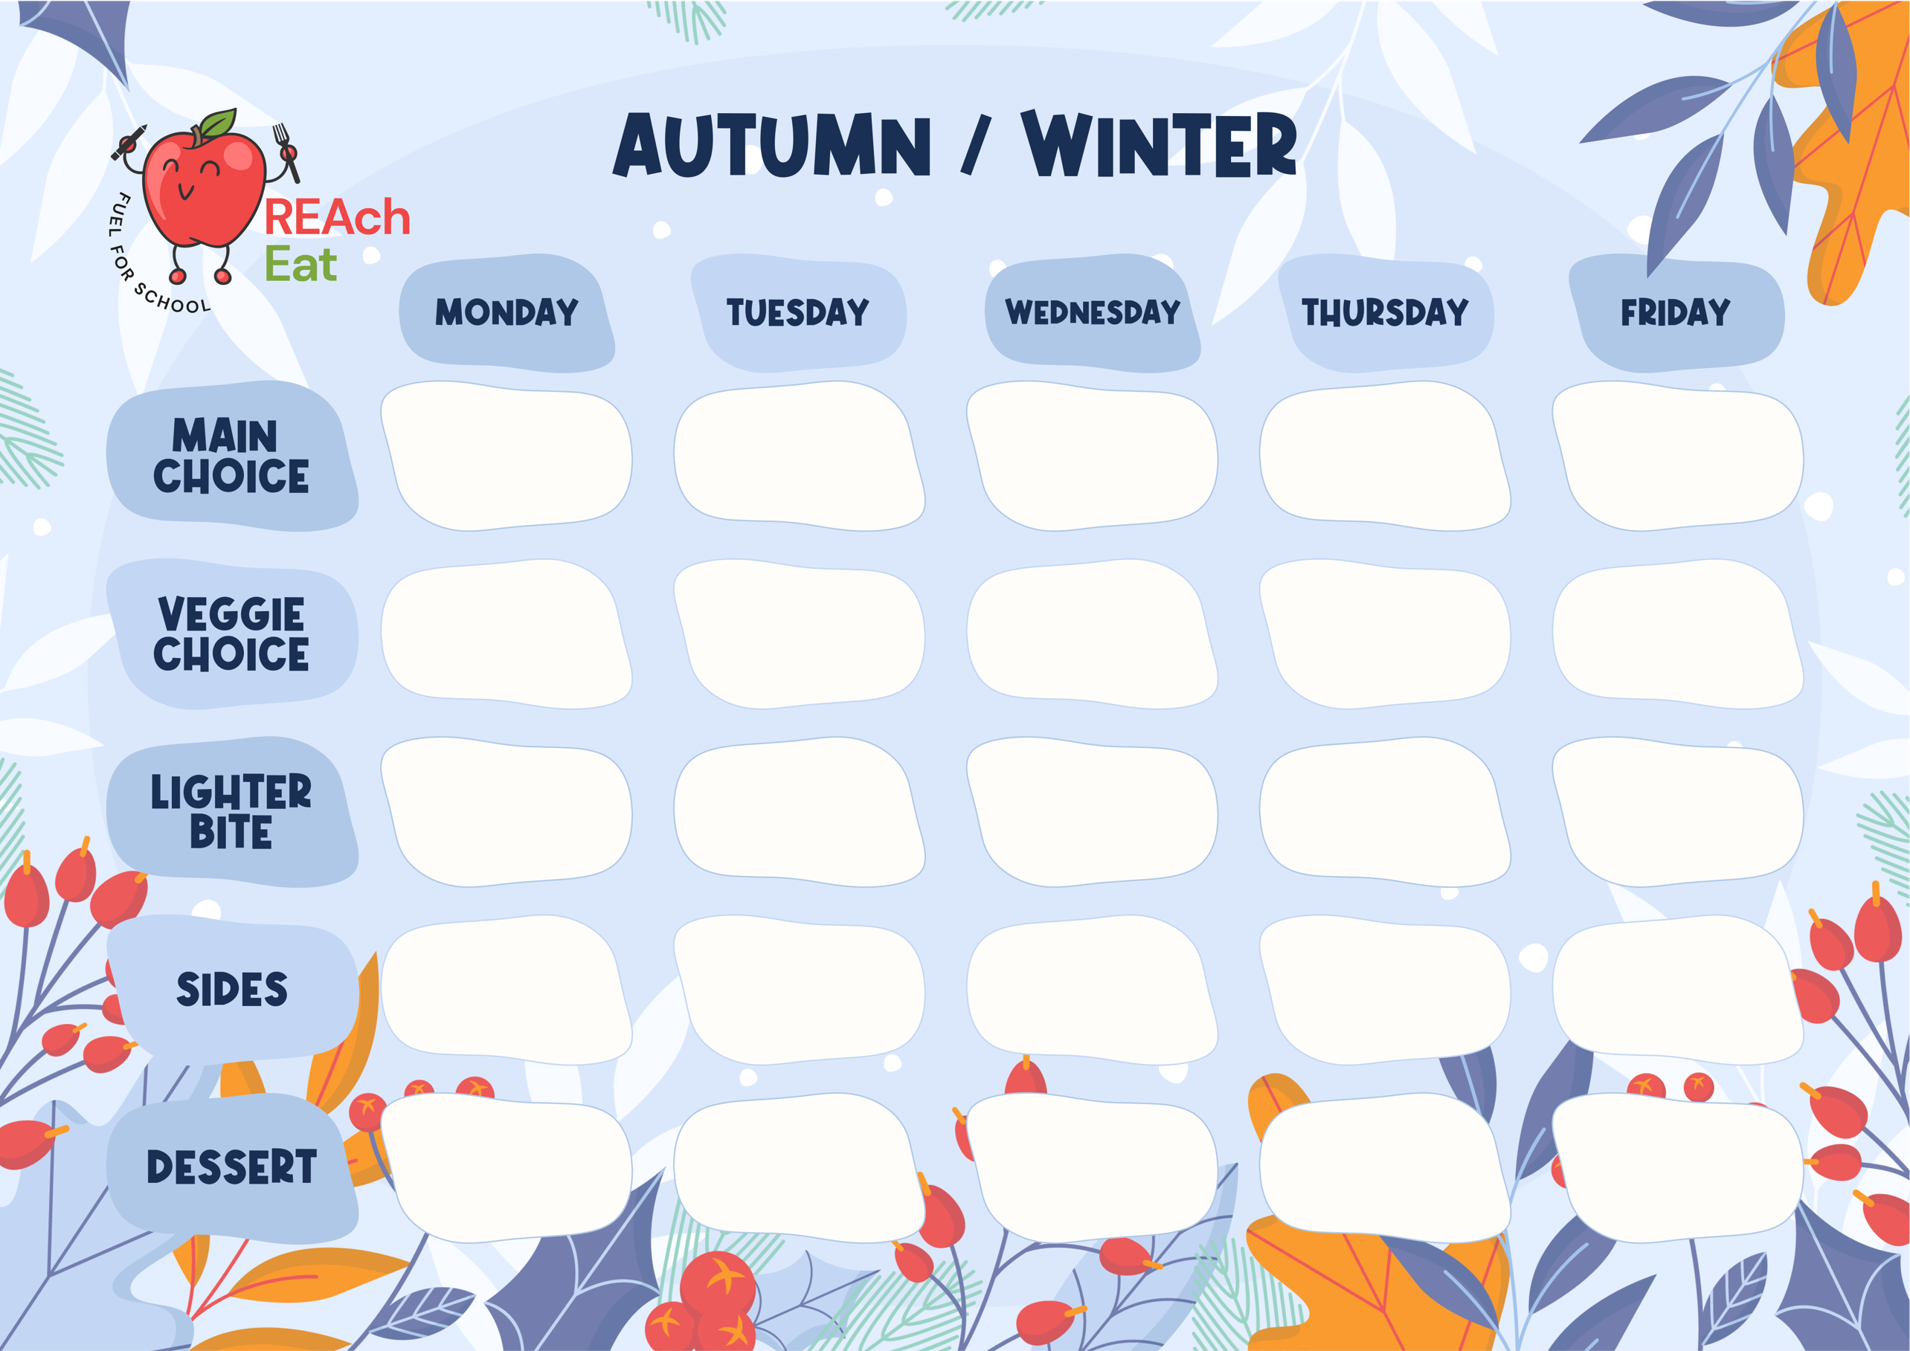
Spring/ Summer
Bread, Yoghurt, Salad Bar, Milk & Water available daily

Plant Based Fish Fingers 6
Choc Chip Cookie 5,6,7 & Milkshake 7 Fresh Fruit & Yoghurt 7
Quorn & Vegetable Wrap 6 with Salad Garnish
Grated Cheese in a Soft Roll 4,6,7 with Side Salad

Allergens - 1 = Peanuts. 2 = Tree Nuts. 3 = Egg. 4 = Sesame. 5 = Soya. 6 = Gluten. 7 = Milk. 8 = Celery. 9 = Mustard. 10 = Fish. 11 = Crustaceans. 12 = Molluscs. 13 = Sulphites. 14 = Lupin.

Vegan & Gluten Free options available daily

Week 2
Omega Three Fish Fingers 6,10
Children’s Favourite Sausage Roll 3,6,7,9
Pot Roast Beef with Gravy
Sliced Chicken, Gravy 6,8 Dumplings 3,5,6,7. & Root Mash
A slice of Cheese & Tomato Pizza 6,7

Vegetarian Sausage Turnover 3,5,6
Tomato & Basil Pasta 6,7 with Garlic Bread 5,6,7
Sliced Sage & Onion topped Quorn Fillet 6 with & Gravy
Vegan Sausage Roll 6
Tuna Mayo in a Soft Roll 4,6,7,9,10 served with a Side Salad
Tandoori Chicken 1,2,7,9,13 with Naan 6 and Mint Yoghurt 3,7
Jacket Potato with Baked Beans
Pear & Chocolate Crumble 6 Ice Cream 7, Fresh Fruit & Yoghurt
Victoria Sponge Finger 3,5,6,7 Fresh Fruit & Yoghurt 7
Apple Pancake 3,6,7 Fresh Fruit & Yoghurt 7

Warmed Pasta Salad 6 Cucumber & Tomato Salad
Broccoli & Mini Sweetcorn Cobs Salad bar
Salad bar

Crispy Potatoes Roasted Vegetables
Creamy Mash Potato 7 Baked Beans & Peas

Crispy Chips Green Salad, Coleslaw 3,9 & Sweetcorn

Iced Fruit Smoothie Fresh Fruit & Yoghurt 7.

